目录

CHAPTER 1. PERFORMANCE MEASUREMENT AND TOOLS 4

• **Measure what** 4

• **JITed and release mode** 4

• **Visual Studio测并发** 4

• **ETW** 4

• **Visual Studio Profiler** 4

• **单独使用VS的Profiler——VsPerf.exe** 6

• **Profiling四种模式** 7

• **Performance Counter —— PerfMon.exe** 7

• **ETW Events** 7

• **Perf View** 7

• **WinDbg and SOS** 8

• **CLR MD** 9

• **BenchmarkDotNet** 11

CHAPTER 2. Memory Management 12

• **Allocation Process** 12

• **Garbage Collection Operation** 13

• **Manipulate GC** 15

• **By configuration – Workstation VS Server, Background** 15

• **By configuration – Latency Modes** 16

• **Collect objects in gen 0 or not at all** 18

• **Avoid Complex Object Graph** 19

• **Avoid Finalizer** 19

• **Avoid Large Object Allocations** 21

• **Pool Long-Lived and Large Objects** 24

**Code P102** 24

• **Case Study: RecyclableMemoryStream** 24

• **Reduce Large Object Heap Fragmentation** 26

• **Get Notified of Collections Before They Happen** 26

• **Get Notified of Collections Before They Happen** 27

• **Use Weak References For Caching** 31

P124 33

• **Dynamically Allocate on the Stack** 33

• **Investigating Memory and GC** 33

• **How Long Does a Collection Take?** 35

**PerfView P136 其中由GC造成的** 35

• **Where Are My Allocations Occurring?** 35

• **What Are All The Objects On The Heap?** 35

2. **PerfView find the stack by “Take Snapshot on Heap”** 35

• **Where Is the Memory Leak?** 35

• **How Big Are My Objects?** 35

• **Which Objects Are Being Allocated On the LOH?** 36

• **Where Is Fragmentation Occuring?** 37

• **What Generation Is An Object In?** 37

**2.** **CLRMD** 37

• **Which Objects Survive Gen 0?** 38

• **What Finalizable Objects Are On The Heap?** 40

CHAPTER 4. Asynchronous Programming 41

• **用多线程的三种情况** 41

• **The Thread Pool** 41

线程池的两个职责：要跑的时候总有线程能跑，没有太多线程在跑 42

• **The Task Parallel Library** 42

**如果需要Continue之后的操作和当前在一个线程中，用以下** 43

• **Continuations与性能案例** 43

**根据执行情况来跳转Continuation** 43

**根据许多前置来Continuation** 44

• **Task Cancellation** 44

• **Handling exceptions** 45

• **Child Task** 48

• Parallel Loops 51

Task与Async Functions 55

Thread Synchronization and Locks 57

Lock内部的顺序都会保证，不会重排， 59

Lock At a Higher Level 61

Investigating Threads and Contention 65

# CHAPTER 1. PERFORMANCE MEASUREMENT AND TOOLS

* **Measure what**: 记录平均时间与分位数时间。You need one “order of magnitude" more samples than the target percentile. For percentiles from 0{99, you need 100 samples minimum. You need 1,000 samples for 99.9th percentile, 10,000 samples for 99.99th percentile, and so on
* **JITed and release mode**
* **Visual Studio测并发**：Concurrency Visualizer (Tools j Extensions and Updates. . . menu).
* **ETW**
  + Event Tracing for Windows and this is the operating system's way of logging all interesting events in an extremely fast, effcient manner.
  + Chapter 8
* **Visual Studio Profiler**

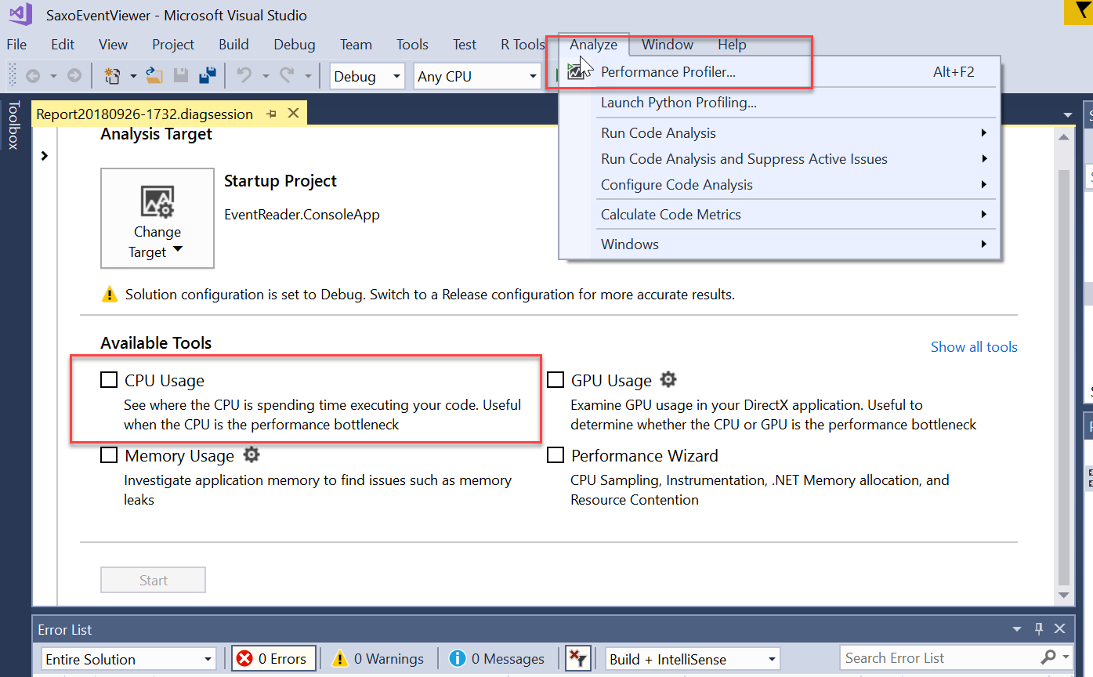

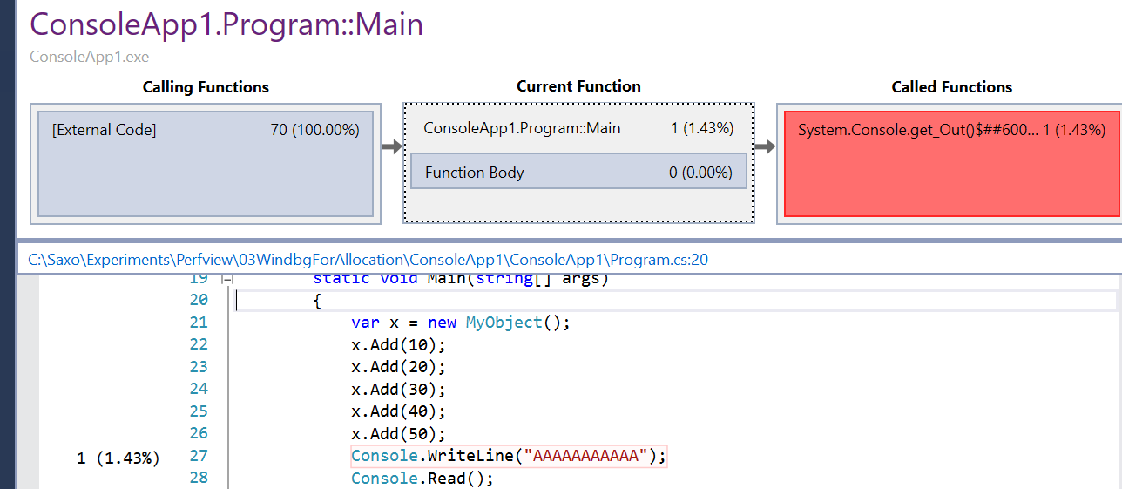

CPU Usage Method Call/Callee Diagram. Shows the most expensive parts of a method.

* **单独使用VS的Profiler——VsPerf.exe**

For Visual Studio 2017, the executable is VsPerf.exe and is located in C:\Program Files (x86)nMicrosoft Visual Studion2017、EnterprisenTeam Tools\Performance Tools.

To collect data from the command line with this tool:

1. Navigate to the installation folder (or add the folder to your path)

2. Run: VsPerfCmd.exe /Start:Sample /Output:outputfile.vsp

3. Run the program you want to pro_le

4. Run: VsPerfCmd.exe /Shutdown

* **Profiling四种模式**

Sample: 采样方法，适合CPU集中，对IO集中方法没用

Trace：记录每个方法的时间

Coverage: which lines of your code were executed. This is a nice feature to have when running tests to see how much of your product the tests cover.

Concurrency: This mode can tell you if your threads are being blocked due to contention. Chapter 4

* **Performance Counter —— PerfMon.exe**

P20 Key concepts

* **ETW Events**

Events are produced by providers. There are providers for nearly every subsystem in Windows, such as the CPU, disk, network, firewall, memory, and many, many more.

* **Perf View**

During event collection, PerfView captures ETW events for all processes.

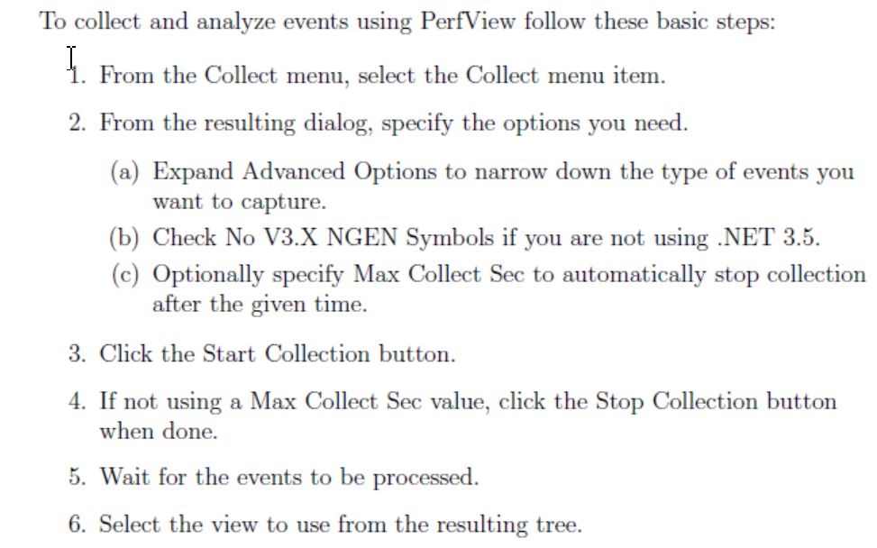

* **WinDbg and SOS**

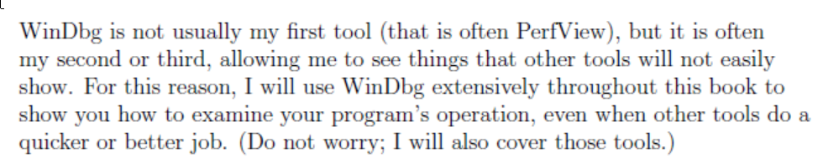

1. Install Windows SDK.
2. Go to File | Attach to Process (or hit F6) to bring up the Attach to Process dialog.
3. load the CLR debugging extensions. **.loadby sos clr**
4. \Unable to _nd module `clr' "？ **sxe ld clr g**
5. prints out some general debugging information about the process **!ProcInfo**

* **CLR MD**

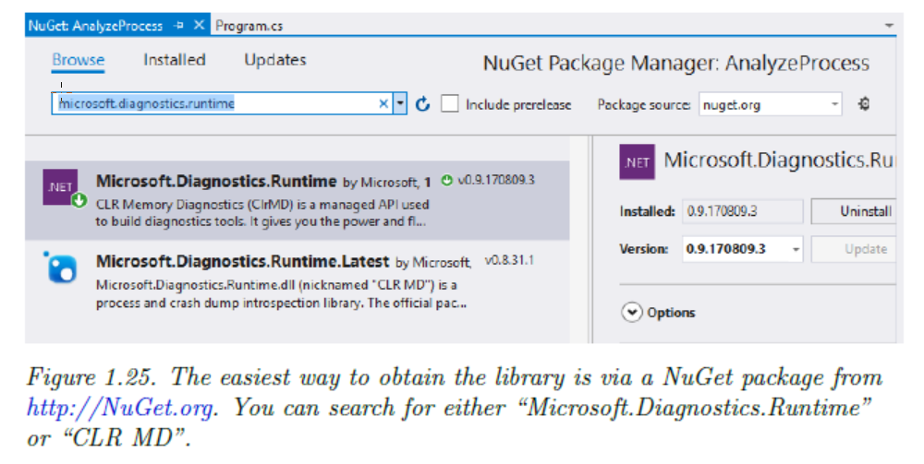

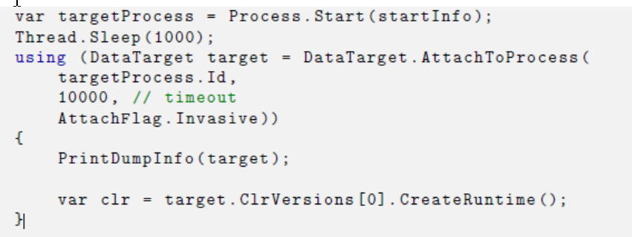

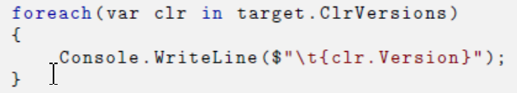

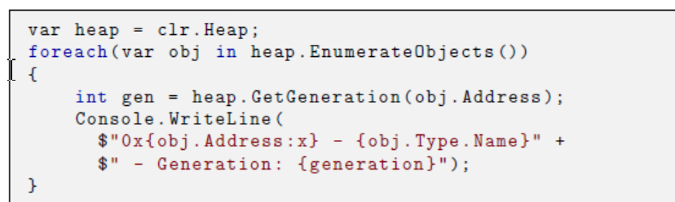

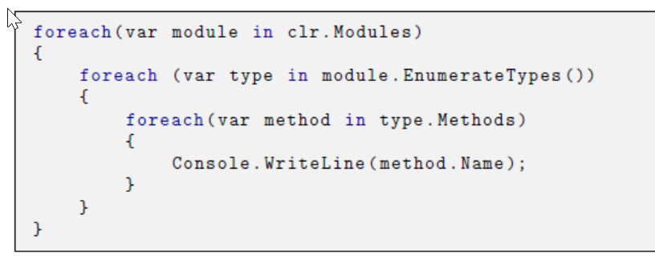

* **BenchmarkDotNet**

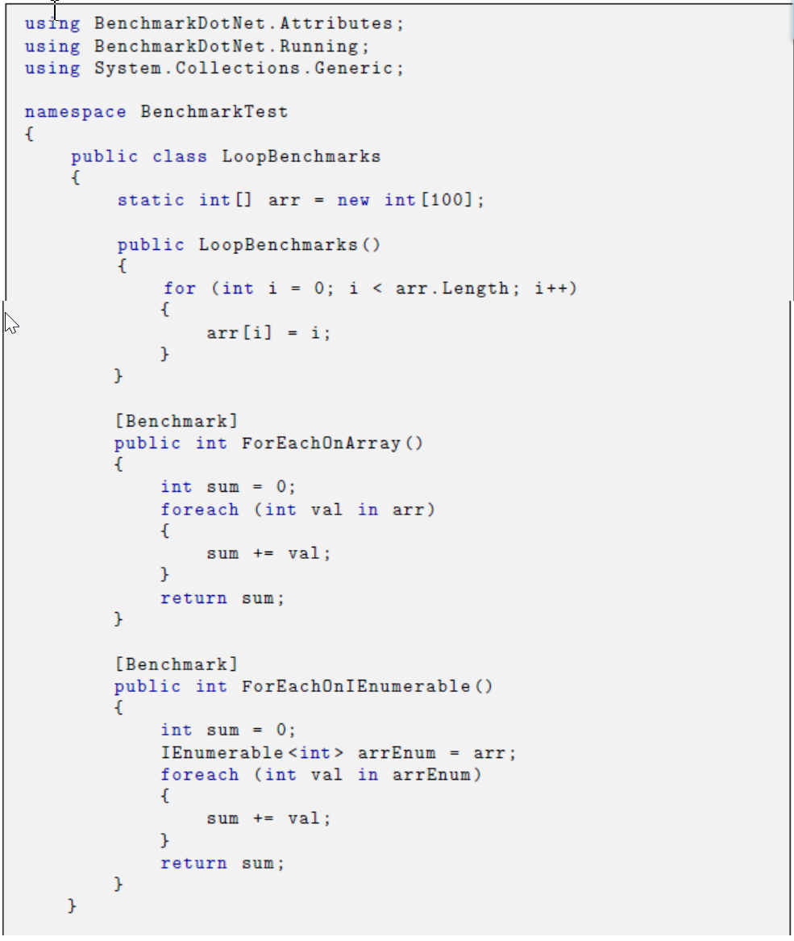

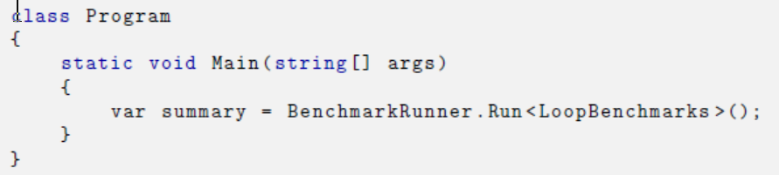

# CHAPTER 2. Memory Management

* **Allocation Process**

In the default allocation path, a small code stub will check the desired object's size against the space remaining in a small allocation bu_er. As long as the allo-cation _ts, it is extremely fast and has no contention. Once the allocation bu_er is exhausted, the GC allocator will take over and _nd a spot for the object (this may involve the use of free lists). Then a new allocation bu_er will be reserved for future allocation requests. 有快慢两种分配路径，buffer不够进慢路径，有finalizer进慢路径。Server GC不分快慢路径，每个处理器一个heap

If the allocation bu_er is not large enough or the end of the segment has been reached, then the slow path will be called. if the object being allo-cated implements a finalizer, then the garbage collector will call the slow path as well.

If you are using some con_guration options such as server GC, then there is not even contention for the fast or the slow allocation path because there is a heap for every processor.

* **Garbage Collection Operation**

In a managed process, there are two types of heaps: unmanaged and managed. Unmanaged heaps are allocated with the VirtualAlloc Windows API and used by the operating system and CLR for unmanaged memory such as that for the Windows API, OS data structures, and even much of the CLR. The CLR allo-cates all managed .NET objects on the managed heap, also called the GC heap, because the objects on it are subject to garbage collection. 托管进程有两种heap，managed与unmanaged。操作系统会用Unmanaged heap放用于操作系统数据结构，CLR用managed heap存放.net对象，叫GC heap

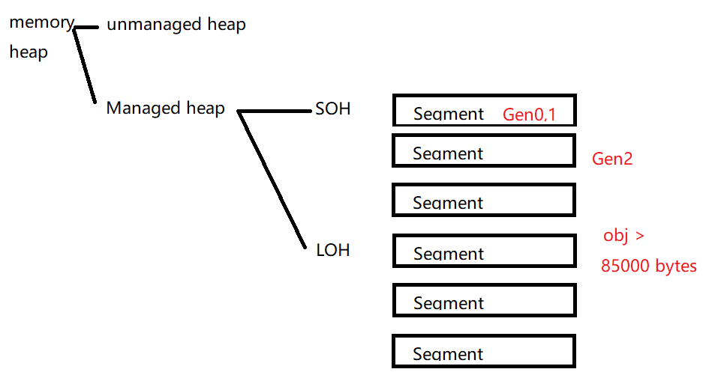

In a managed process, there are two types of heaps: unmanaged and managed. Unmanaged heaps are allocated with the VirtualAlloc Windows API and used by the operating system and CLR for unmanaged Managed heap再分LOH和SOH，每一个Heap包含很多内存segment。 SOH再分成多个Generation，01在一个Segment，2有多个Segment。LOH的对象直接就是Gen2，通常是array和string

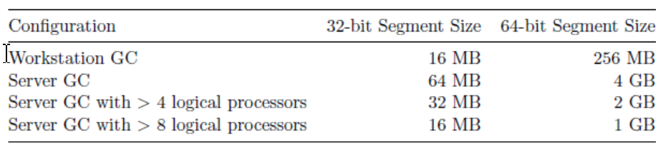

So what does alive mean? If the GC can reach the object via any of the known GC roots, following the graph of object references, then it is alive. Note that you may have ob-jects that no longer have roots to them, but if the objects are in gen 2, then a gen 0 collection will not clean them up. They will have to wait for a full collec-tion. 如果root在Gen2还没回收，child在Gen0也不会被回收

If gen 0 ever starts to _ll up a segment and a collection cannot compact it enough, then the GC will allocate a new segment. The new segment will house a new gen 1 and gen 0 while the old segment is converted to gen 2. Everything from the old generation 0 becomes part of the new generation 1 and the old genera- tion 1 is likewise promoted to generation 2 (which conveniently does not have to be copied). **开始时Gen01共用一个Segment，如果分配到Gen0不够了，会开一个新的Segment作为Gen01，老的Gen0全进新的Gen1，老的Gen1全进Gen2，方法是老的Gen01 Segment直接变成Gen2的Segment, 不用拷贝Gen1到Gen2****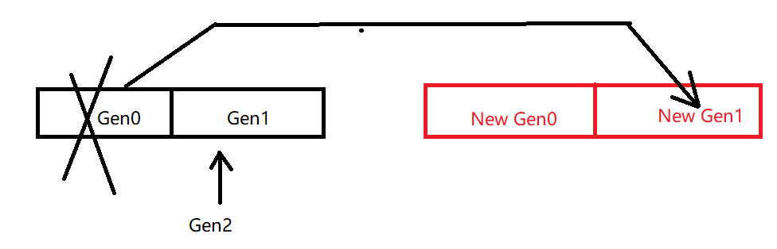**

A garbage collection runs for a speci_c generation and all generations below it. There are four phases to a garbage collection: Suspension, mark, Compact，Resume **收Gen1会连带收Gen0，收Gen2会收1和0. 收01程序会暂停，收2可以在后台。回收四阶段。如果线程多，回收暂停也会花很多时间。**

The frequency of a garbage collection is primarily determined by how much memory is allocated in a speci_c generation. Once that amount passes an internal threshold, a GC will happen for that generation. Another trigger for GCs is the total available memory on a machine. 回收频率有已用Gen大小决定，也受全部可以内存影响

* **Manipulate GC**

It requires understanding of how the GC works, your allocation rate, how well you control object lifetimes, and what conguration options are available to you. 要知道GC工作方式，你的分配频率，控制对象生命期的程度，

* **By configuration – Workstation VS Server, Background**

Workstation GC is the default. In this mode, all GCs happen on the same threadthat triggered the collection and run at the same priority. Server GC creates a dedicated thread for each logical processor or core. Within each processor heap, there is a small object heap and a large object heap. 总共一个Heap，一个单独的低优先级回收Thread，停下程序回收是Workstation；每个Core一个高优先级的回收Thread,每个Core一个Heap， 回收时也会暂停应用程序线程，是Server GC，每个heap有自己的SOH和LOH，Allocation会快（都会停应用程序线程，要不要停是看Background）

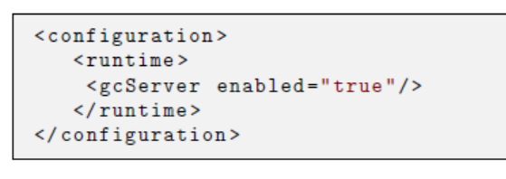

If your app is running on a multi-processor machine dedicated to just your application, then the choice is clear: server GC. On the other hand, if you need to share the machine with multiple managed processes, 用Workstation因为Server GC会出现很多高优先级的回收线程，阻碍其他应用线程

Background GC changes how the garbage collector performs **gen 2** collections by allowing it to occur more often in the background while other threads are executing. Background GC指**Gen2**的回收在后台，Gen01仍然在前台。Workstation GC下默认就用Background GC；在Server GC下开background GC，每个Core会有两个回收线程，一个前台高优先级线程，停下应用程序后回收，一个后台低优先级线程，不停应用程序线程就能回收Gen2。.Net 4.5后都是默认打开的

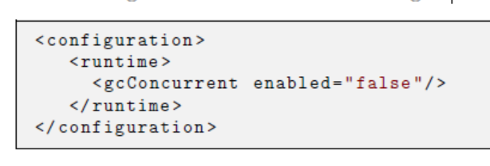

* **By configuration – Latency Modes**

If you have periods of time that require critical performance, you can tell the GC not to perform expensive gen 2 collections. 停止Gen2回收一段时间。打开以后Heap不会压缩，内存占用会扩大。所以使用之前先GC.Collect(2, GCCollectionMode.Forced). 使用后在回收一次

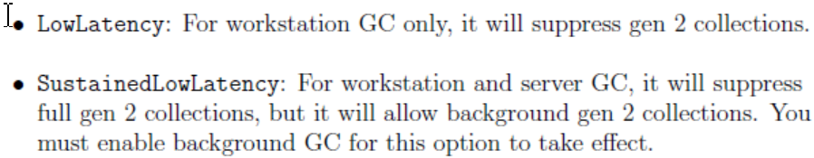

Right before entering one of these modes, it is a good idea to force a last full GC by calling GC.Collect(2, GCCollectionMode.Forced). Once your code leaves this mode, do another GC.

You can declare regions where garbage collections are disallowed, using the NoGCRegion mode.

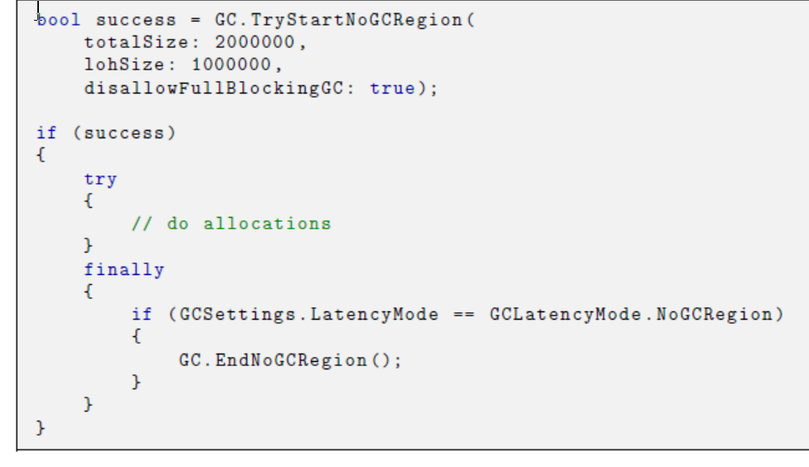

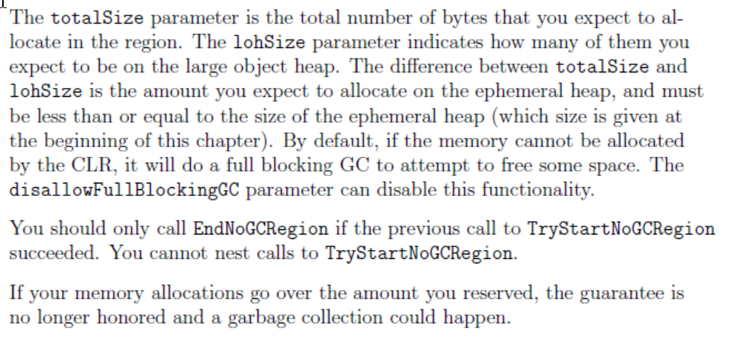

* **Collect objects in gen 0 or not at all**

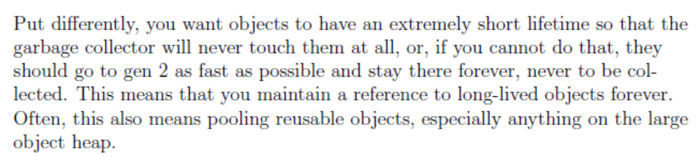

You can measure how long that interval is and compare it to the duration that data is alive in your application. Ideally, every object you allocate goes out of scope by the time the next gen 0 comes around. 测一下开始回收的间隔周期有多长，object存在的时间有多长，然后保证object能在下一次回收前失效。要用前才创建，用完就失效

* **Avoid Complex Object Graph**

Objects that have many references to other objects will take more time for the garbage collector to traverse. A long GC pause time is often an indication of a large, complex object graph.

* **Avoid Finalizer**

Never implement a finalizer unless it is required. Finalizers are code, triggered by the garbage collector to cleanup unmanaged resources. They are called from a single thread, one after the other, and only after the garbage collector declares the object dead after a collection. The FInalizer thread is triggered by a garbage **Finalizer是GC用来清理非托管资源的，所有Finalizer会排队，在对象dead后由一个线程按顺序执行。所以GC只有他还在内存中。Finalizer线程由GC来启动**

an object with a finalizer is slower to allocate. Allocate也慢

一定要实现Finalizer时，要调用GC.SuppressFinalize(this)，不把对象加进Fianlizer队列

If you do implement a finalizer, you must also implement the IDisposable interface to enable explicit cleanup, and call GC.SuppressFinalize(this) in the Dispose method to remove the object from the _nalization queue.

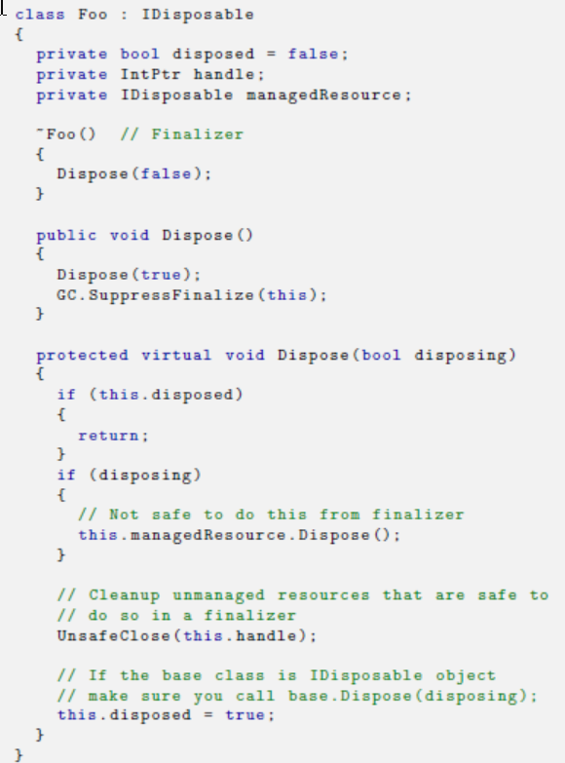

The disposing variable indicates whether a developer explicitly called Dispose. If they did, then it is safe to Dispose of all resources.

However, if this method is called via the _nalizer, then there is no guarantee any refer-enced objects are still valid, so only those unmanaged resources explicitly owned by this object can be safely cleaned up in this method. **如果使用者主动调用了Dispose，那就一下清干净，不用等Finalizer。如果没有主动调，是Fianlizer调了，那就只能清非托管资源。**

Only mark the protected version of Dispose virtual and allow it to be overriden by child types. **实现函数Dispose是protected virtual，另一个Dispose不是，保证子类的Dispose（）也会这么做。**

Dispose methods and finalizers should never throw exceptions, even as simple as logging.

* **Avoid Large Object Allocations**

You should usually avoid copying data whenever you can. For example, suppose you have read _le data into a MemoryStream (preferably a pooled one if you need large buffers). Once you have that memory allocated, treat it as read-only and every component that needs to access it will read from the same copy of the data. **避免拷贝一大块内存buffer，都从同一个地方读取。**可以用ArraySegment来引用Stream中的一段，并传来传去**；或者用Span,ReadOnlySpan**

ArraySegment<T> struct to represent just a portion of the underlying array. This ArraySegment can be passed around to APIs independent of the original stream, and you can even attach a new MemoryStream to just that segment. Throughout all of this, no copy of the data has been made.

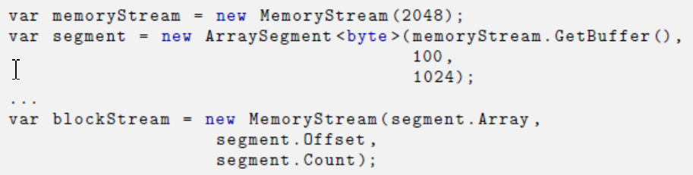

Span<T> is like an array in the sense that it represents a contiguous block of memory, but it has the distinction of being able to wrap managed memory, unmanaged memory, and stack memory with the same abstraction. System.Memory NuGet package and use Visual Studio 2017 Span会使用ref来避免内存分配，如果是string会用readonlySpan

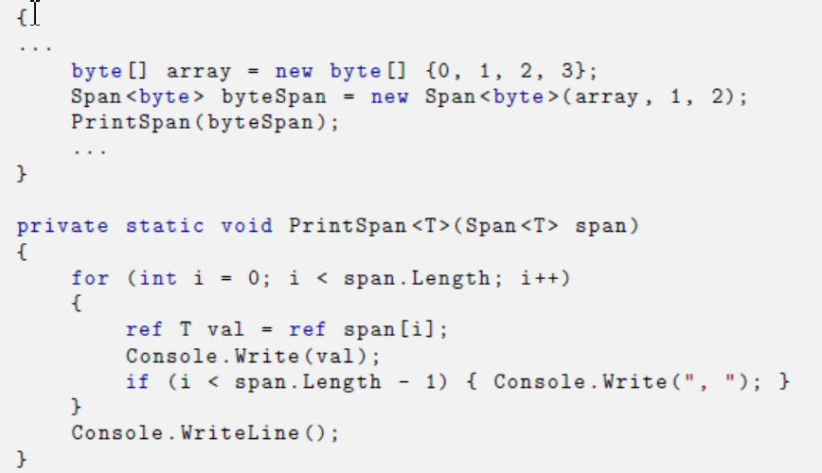

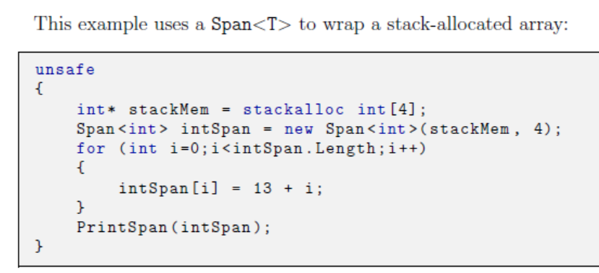

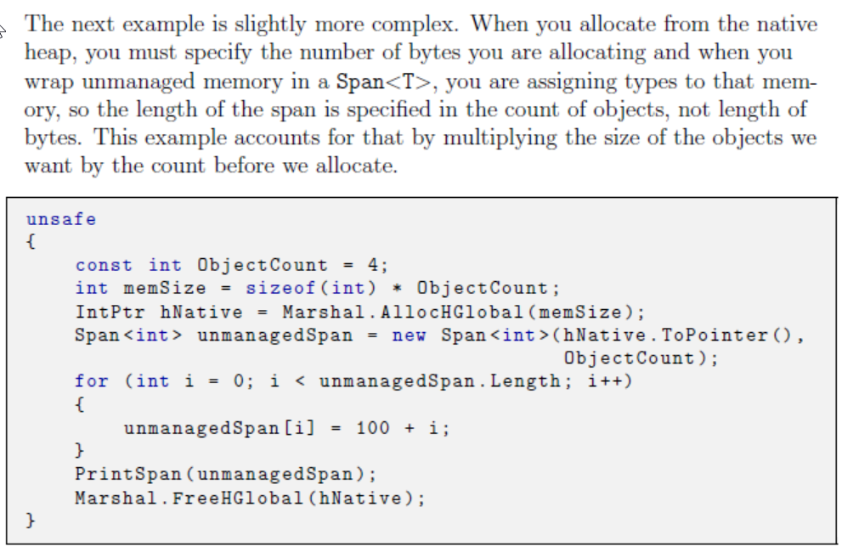

* **Pool Long-Lived and Large Objects**

Some objects are essentially static they are created and last the lifetime of the program naturally. Other objects do not obviously need to last forever, but their natural lifetime in the context of your program ensures they will live longer than the period of a gen 0 (and maybe gen 1) garbage collection. These types of objects are candidates for pooling. Another strong candidate for pooling is any object that you allocate on the large object heap, typically collections. **对象要么在Gen0 Gen1结束，要么永远留在Gen2不变。对于肯定会超过Gen0 Gen1但会变的对象可以Pool起来**

**Code P102**

A reasonable design is to derive a new type and have it implement IDisposable, where the Dispose method puts the pooled object back in

the pool. This will be a strong clue to users of that type that they need to treat this resource specially.

An additional strategy is to have your poolable types implement a _nalizer as a safety mechanism. If the _nalizer runs, it means that Dispose was never called, which is a bug. You can choose to write something to the log, crash, or other-wise signal the problem

Your pool should have a bounded size (in either bytes or number of objects), and once that has been exceeded, it should drop objects for the

GC to clean up.

* **Case Study: RecyclableMemoryStream**

Before you can allocate a RecyclableMemoryStream, you must create the pool manager, a RecyclableMemoryStreamManager object. This is the class that actually manages the buffer pools and tracks resource usage. There is typically one manager object per process and it lives for the lifetime of the process.

https://github.com/Microsoft/Microsoft.IO.RecyclableMemoryStream

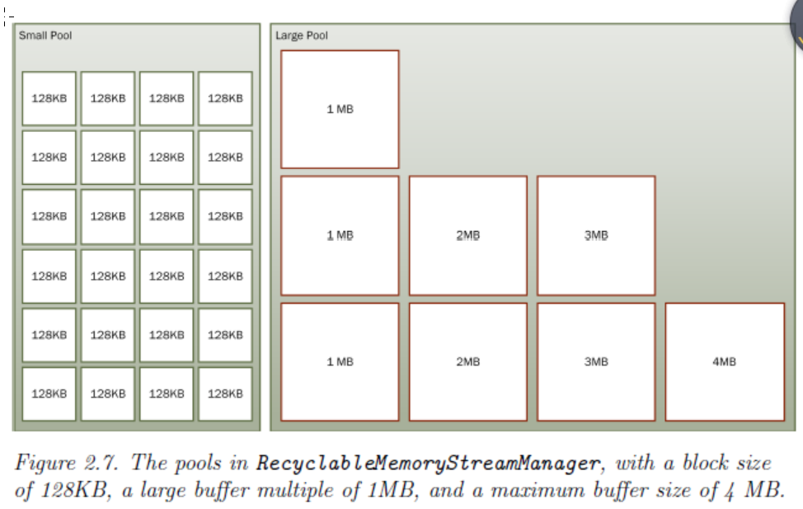

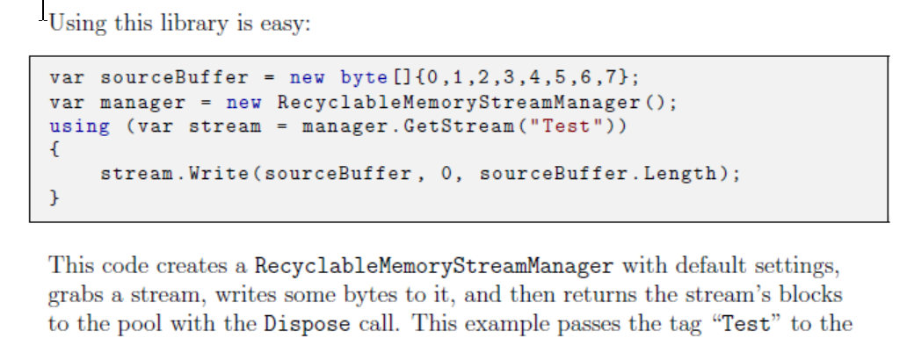

“Test”是个Tag。 调用Read Write只会使用小Blocks，调用GetBuffer会使用连续的Block

As long as just Read and Write methods are used, only blocks will be used. When GetBuffer is called, a contiguous block must be returned.

After converting the stream to a buffer, with an associated data length, it may be useful to wrap them in an ArraySegment<byte> struct.

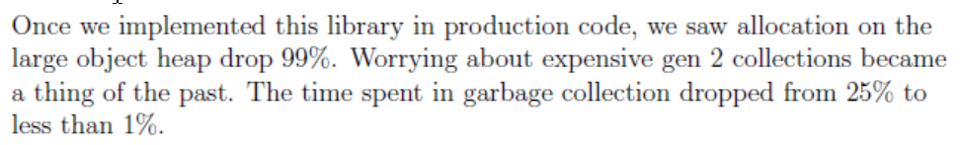

* **Reduce Large Object Heap Fragmentation**

If you cannot completely avoid large object heap allocations, then you want todo your best to avoid fragmentation.

One way to do this is to ensure that all allocations on the LOH are of uniform size, or at least multiples of some standard size. This way, if one of the buffers does need to get garbage collected, there is a high likelihood that the next bu_er allocation can _ll its spot rather than going to the end of the heap.

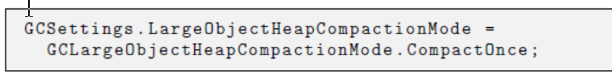

* **Get Notified of Collections Before They Happen**

If your application absolutely should not be impacted by gen 2 collections, thenyou can tell the GC to notify you when a full GC is approaching.

Unfortunately, because of the imprecise nature of GC triggering, you can only specify the pre-trigger time in an approximate way with a number in the range 1-99. With a number that is very low, you will be noti_ed much closer to when the GC will happen, but you risk having the GC occur before you can react to it.

* **Get Notified of Collections Before They Happen**

If your application absolutely should not be impacted by gen 2 collections, thenyou can tell the GC to notify you when a full GC is approaching. This will giveyou a chance to stop processing temporarily **可以代码监控全回收，设置临时取消。**

Note that you specify two numbers: one for the gen 2 threshold and one for the large object heap threshold.

1. Call the GC.RegisterForFullGCNotification method with the two threshold values.
2. Poll the GC with the GC.WaitForFullGCApproach method. This can wait forever or accept a timeout value.
3. If the WaitForFullGCApproach method returns Success, put your program in a state acceptable for a full GC (e.g., turn o_ requests to the machine.
4. Force a full collection yourself by calling the GC.Collect method.
5. Call GC.WaitForFullGCComplete (again with an optional timeout value) to wait for the full GC to compete before continuing.
6. Turn requests back on.
7. When you no longer want to receive noti_cations of full GCs, call the GC.CancelFullGCNotification method.

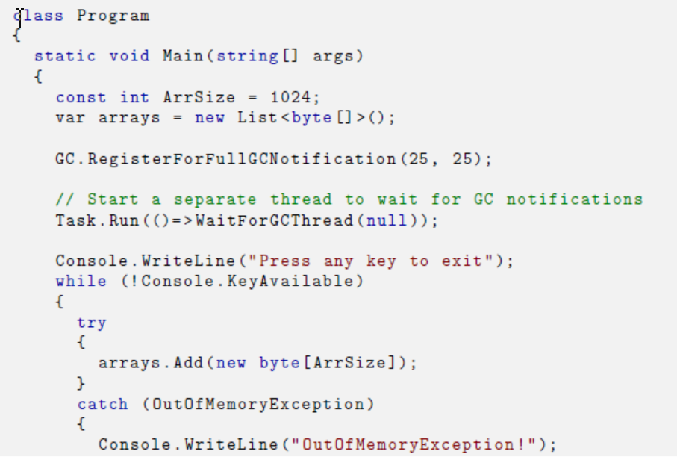

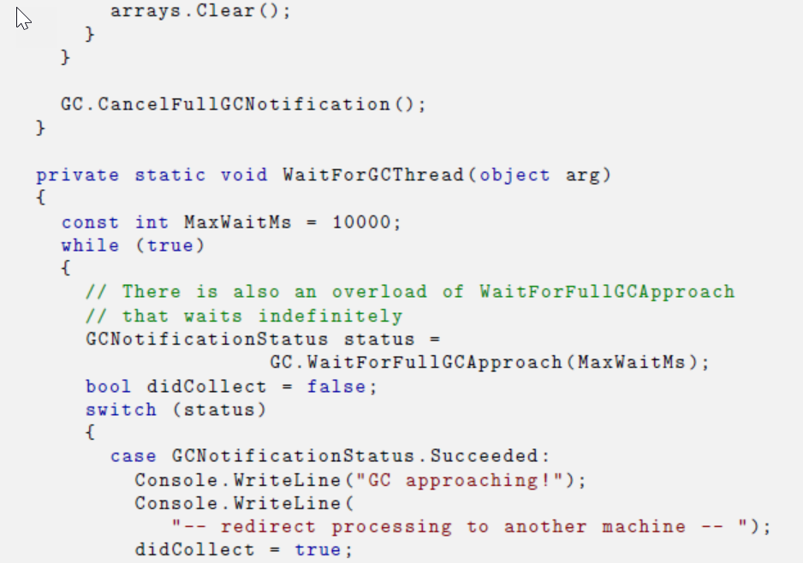

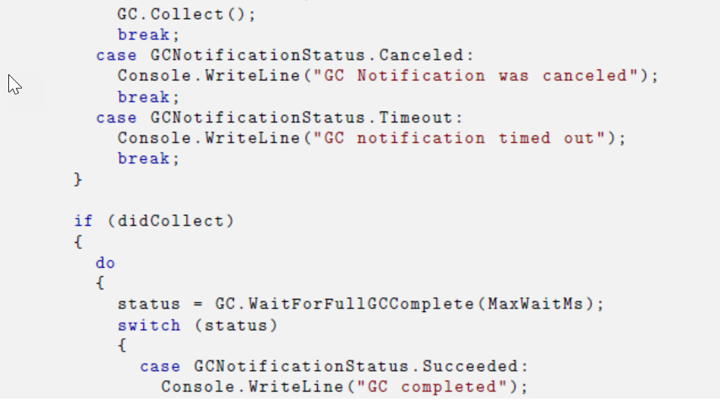

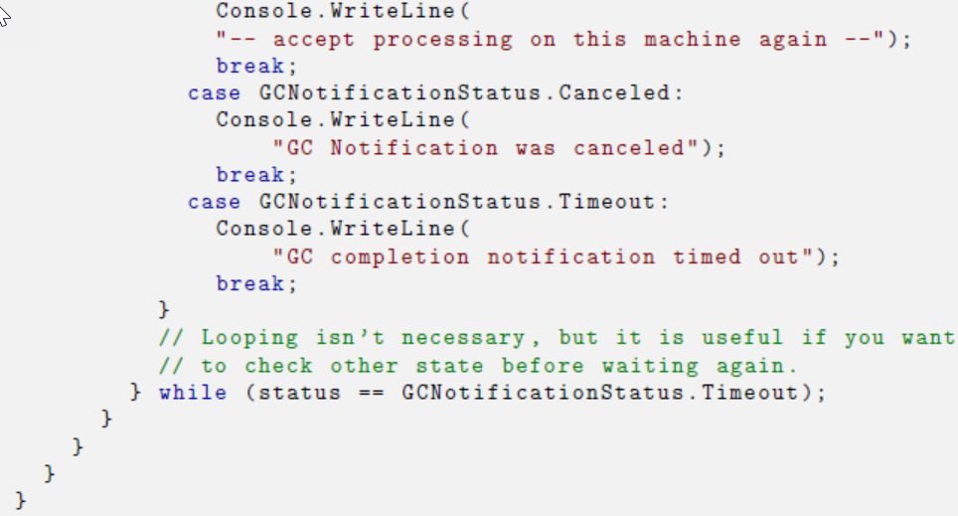

* **Use Weak References For Caching**

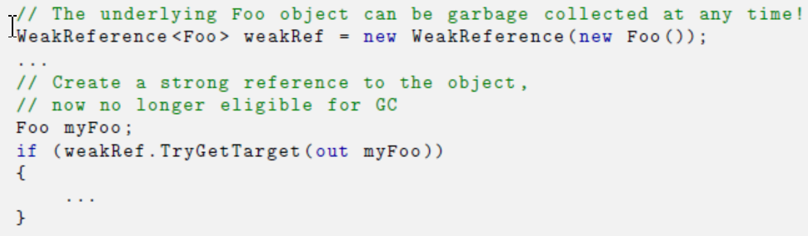

Thankfully, you can reuse these wrapper objects by using the SetTarget method to replace the underlying value as needed. Collection will only happen if the only references to it are weak (or non-existent). **可以不用回收WeakRef本身，而是让它指向新对象**

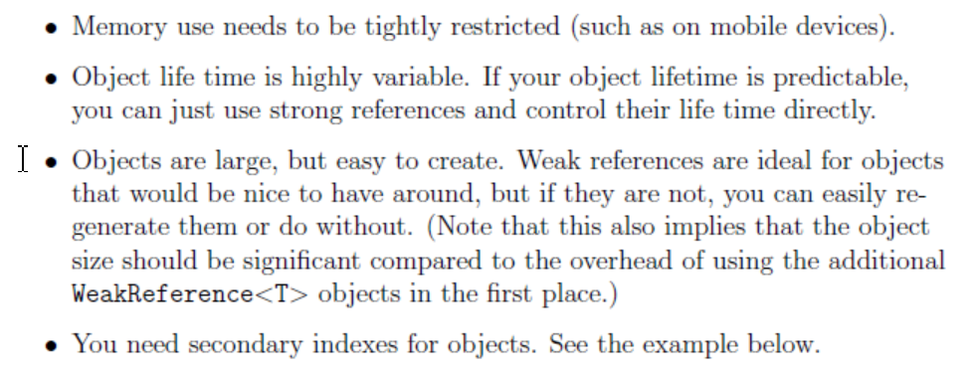

A good way to use WeakReference<T> is as part of a cache. 对象一开始是strong的，一段时间不用后就进入weakref，最后会被回收

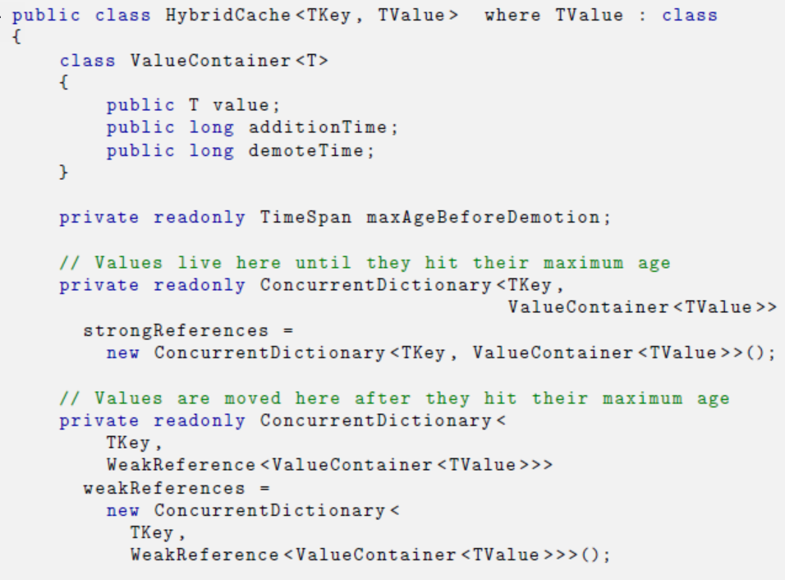

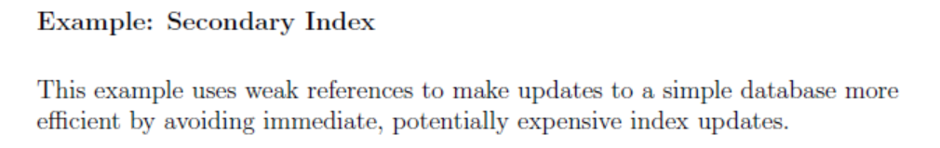

P124

* **Dynamically Allocate on the Stack**

Instead of allocating memory from the heap, it is possible to allocate dynamically sized buffers on the stack using **stackalloc**. Such allocations are faster than heap allocations and incur no garbage collection. limited to 1 megabyte in size

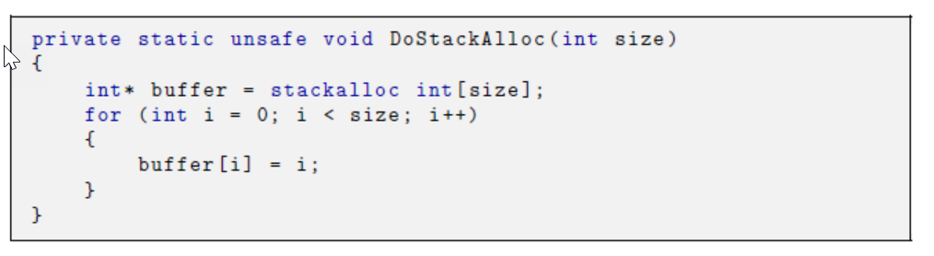

Despite the risks and limitations, stackalloc is a valuable tool when you want small, dynamically sized arrays in your methods without the overhead of a heap allocation.

* **Investigating Memory and GC**
* Performance Counters P127
* ETW

You can examine these in detail in PerfView with the Events view. Through judicious use and analysis of ETW events you can detect whether operations in your application are being a_ected by GC

* What Does My Heap Look Like? – Windbg

!eeheap -gc , !HeapStat, VMMap, !VMStat

* VMMap: <https://docs.microsoft.com/en-us/sysinternals/downloads/vmmap>

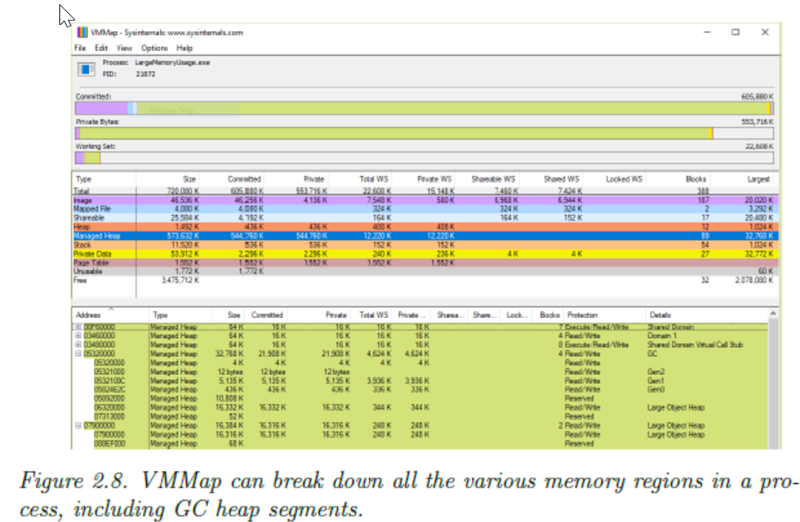

* **How Long Does a Collection Take?**

**PerfView P136 其中由GC造成的**Pauses统计

* **Where Are My Allocations Occurring?**

With PerfView, collect either .NET or just GC Only events.

* **What Are All The Objects On The Heap?**

1. WinDbg !DumpHeap

Dump a specific Object / Objects of a type

1. **PerfView find the stack by “Take Snapshot on Heap”**

* **Where Is the Memory Leak?**

In the Memory menu, select Take Heap Snapshot.

You can double-click the entry for a type, which switches to the Referred-From view.

* **How Big Are My Objects?**

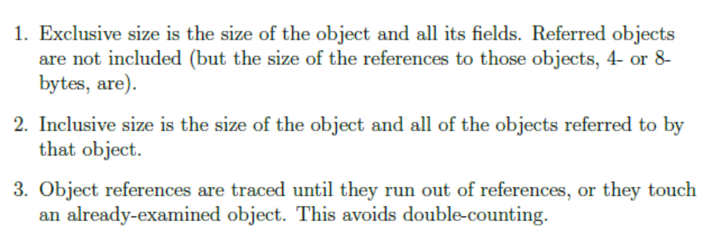

* **Which Objects Are Being Allocated On the LOH?**

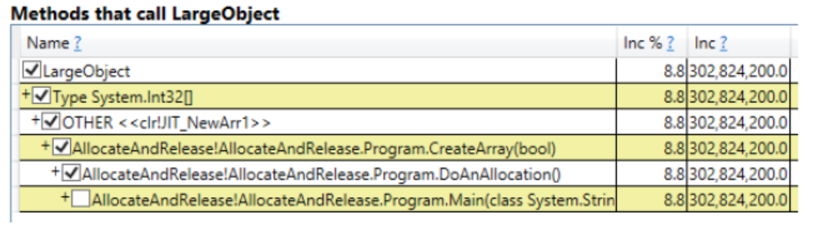

**CLR MD**

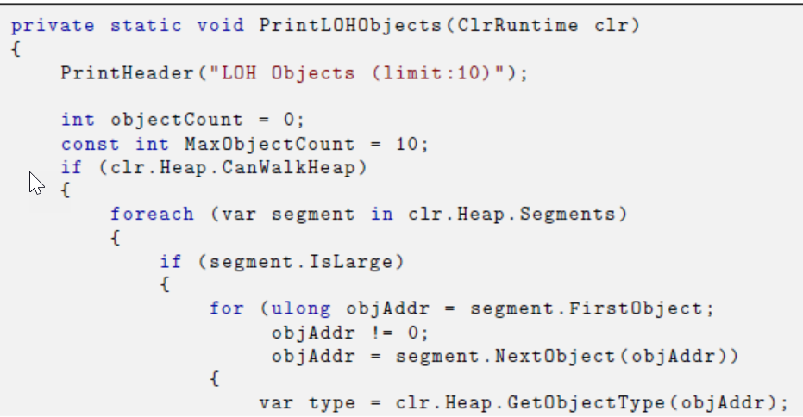

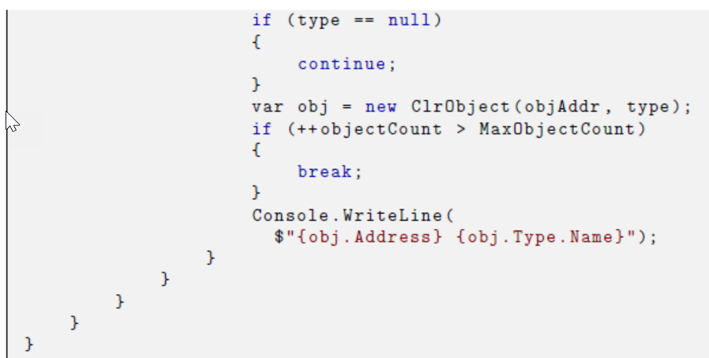

* **Where Is Fragmentation Occuring?**

1. PerfView can also tell you when fragmentation is occurring in the GCStats view. Look at the Frag % columns. However, it does not tell you why, exactly.
2. The CLR MD library allows you to build your own tool to highlight fragmentation for you. Each ClrObject has a Type property, which has an IsFree Boolean property, which indicates if that type represents free space on the heap

* **What Generation Is An Object In?**

1. You can retrieve this information from inside your app's own code by using the GC.GetGeneration method and passing it the object in question.
2. **CLRMD**

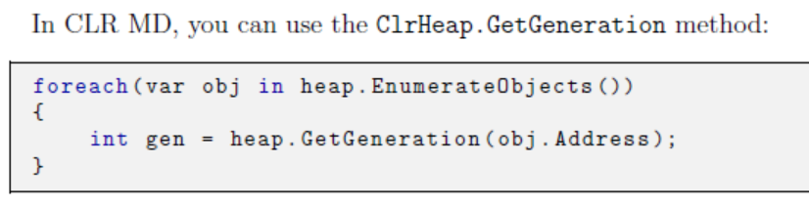

* **Which Objects Survive Gen 0?**

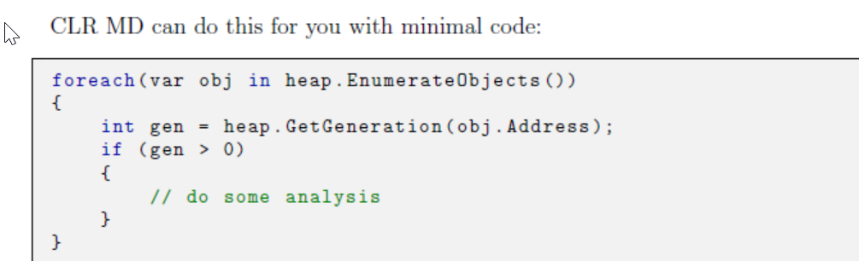

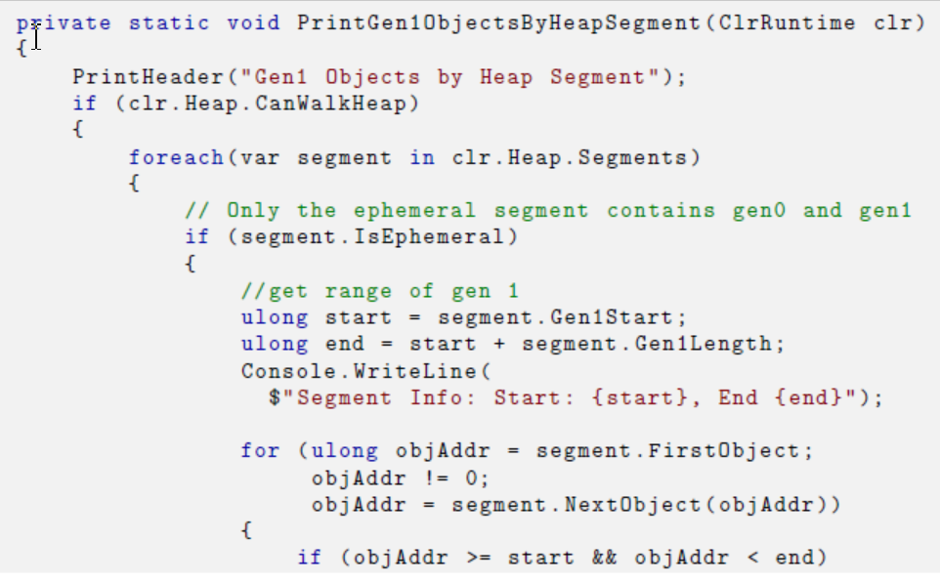

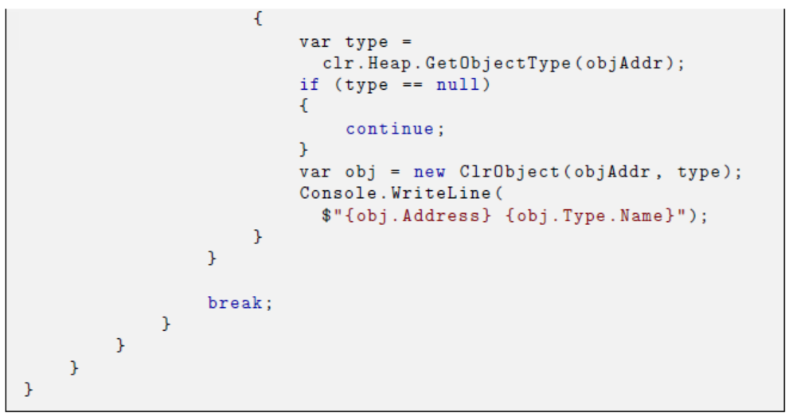

* **What Finalizable Objects Are On The Heap?**

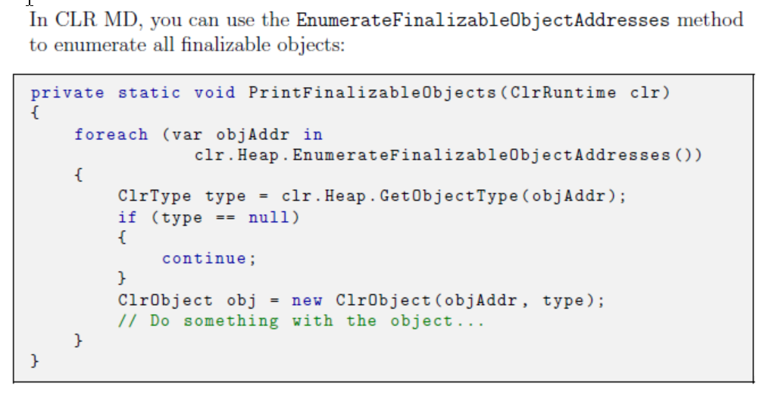

# CHAPTER 4. Asynchronous Programming

## **用多线程的三种情况**

1. 不能block前台UI线程
2. 计算集中，IO的时候也要使用CPU资源
3. 要用上所有处理器

Each processor can execute only a single thread at a time. When it comes time to schedule a thread for a processor, Windows needs to do a context switch. During a context switch, the Windows kernel saves the processor's current thread's state to the operating system's internal thread object, picks from all the highest-priority ready threads, transfers the thread's context information from the thread object to the processor, and then finally starts it executing. If Windows switches to a thread from a di_erent process, even more expense is incurred as the address space is swapped out.

The thread will then execute the code for the thread quantum, which is a multiple of the clock interval (the clock interval is about 15 milliseconds on current multiprocessor systems and cannot easily be changed, nor is it recommended to do so). When the code returns from the top of its stack, enters a wait state, or the time quantum is expired, the scheduler will pick another ready thread to execute. It may be the same thread, or not, depending on the contention for the processors. A thread can enter a wait state if it blocks on I/O of any kind, or voluntarily enters this state by calling Thread.Sleep.

**Clock Interval通常是15ms.** 时间到了换下一个Thread，也可能就换到自己

## **The Thread Pool**

Creating new threads is an expensive procedure. Once avail-able, they can be reused for the next piece of work.

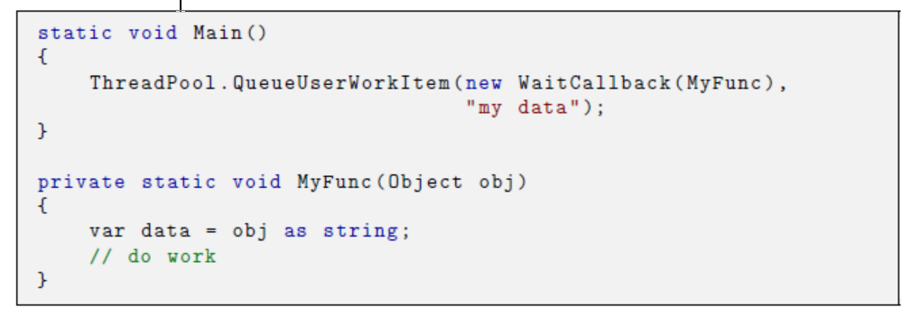

It needs to ensure that there is an available thread to handle any tasks that come its way, but it also needs to ensure that there are not too many threads running.

线程池的两个职责：要跑的时候总有线程能跑，没有太多线程在跑

If you have many tasks that take more than a few hundred milliseconds to execute, the thread pool will not be as executive.

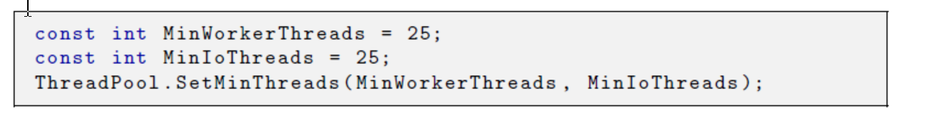

To reach the steady state sooner,you can tweak the startup parameters to maintain a minimum number of ready threads upon startup

## **The Task Parallel Library**

However, if your code consists of many smaller than the thread quantum ( 15ms ), tasks that are unlikely to take this long, using threads directly is inefficient.

Internally, the TPL uses the .NET thread pool, but does so more efficiently

**如果需要Continue之后的操作和当前在一个线程中，用以下**



## **Continuations与性能案例**

**根据执行情况来跳转Continuation**

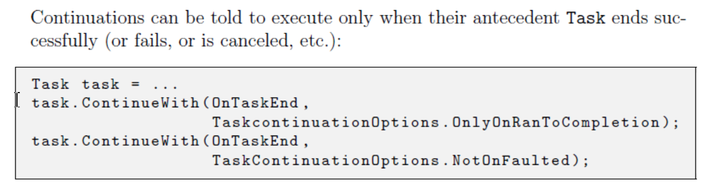

**根据许多前置来Continuation**

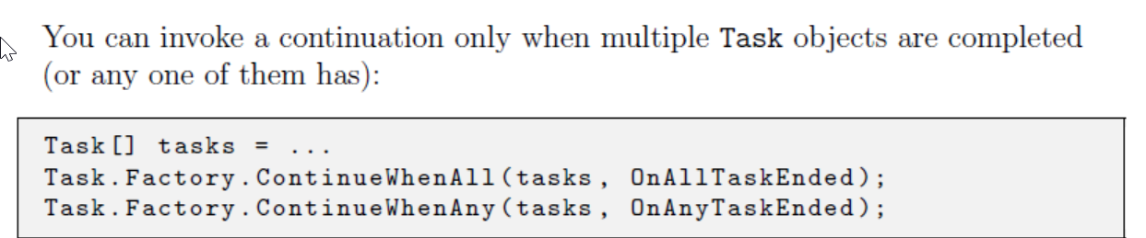

## **Task Cancellation**

CancellationToken

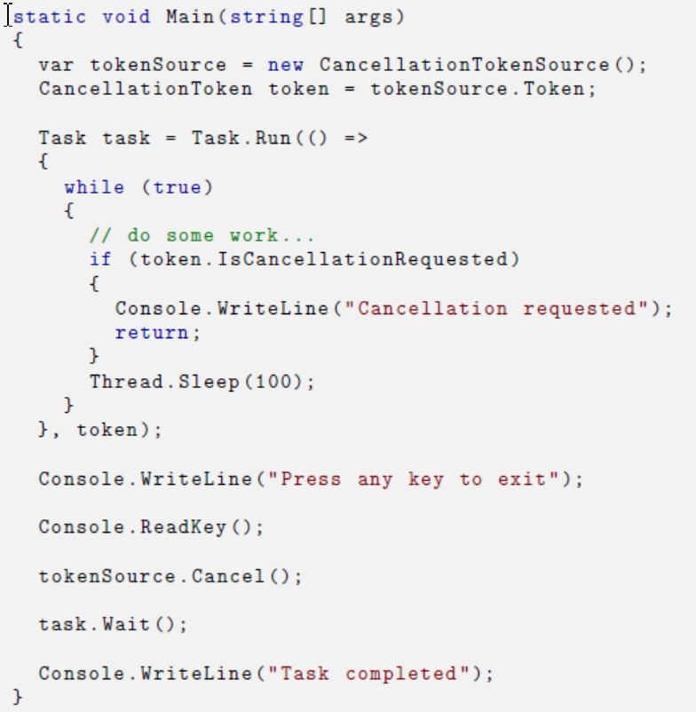

## **Handling exceptions**

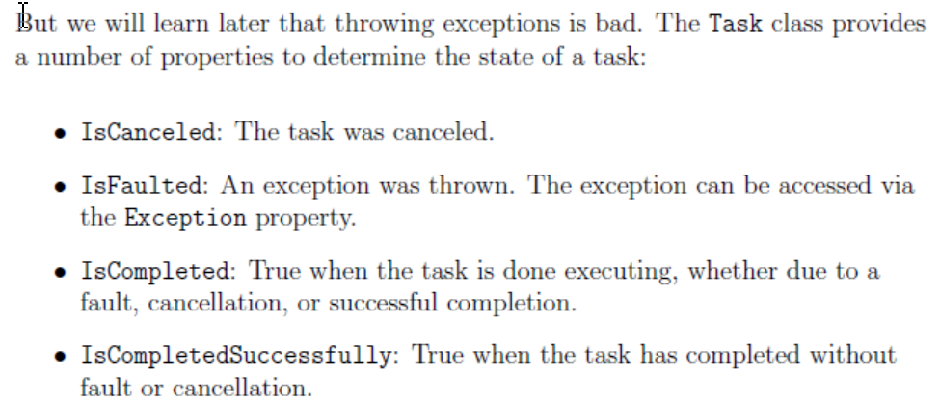

Before .NET 4.5, if a Task's exception went unobserved, it would crash the process. When it goes unobserved, an object will be put in the finalization queue that knows about it. The next time the garbage collector runs finalizers, the exception will be thrown.

没有抓住的Exception会留在Finalization queue中，下一次GC跑Finalizer时会抛出异常

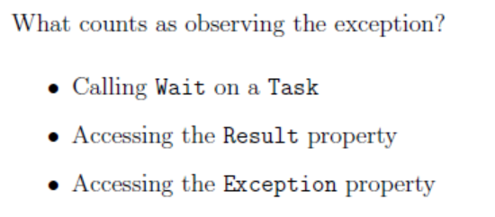

4.5之后可以设置，将这些Exception抛到统一的接口

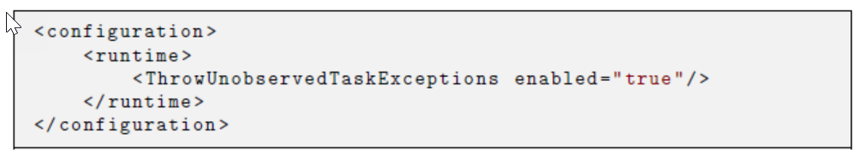

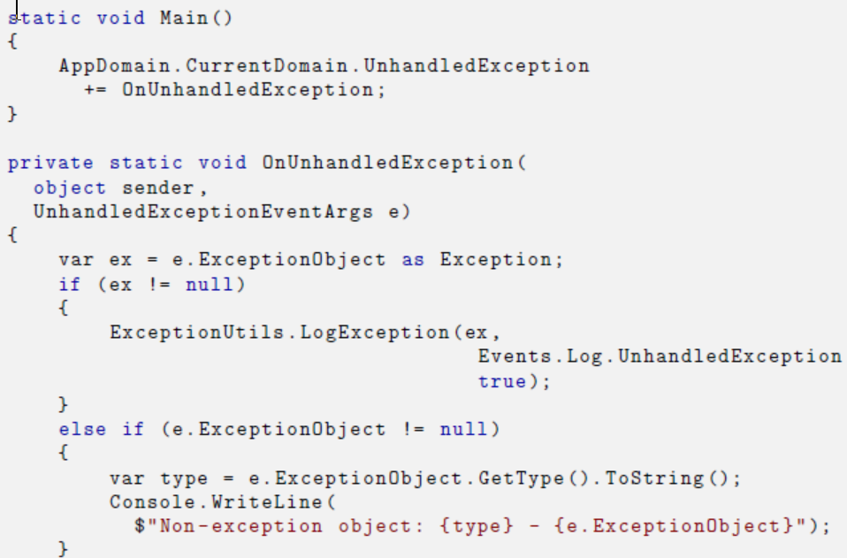

## **Child Task**

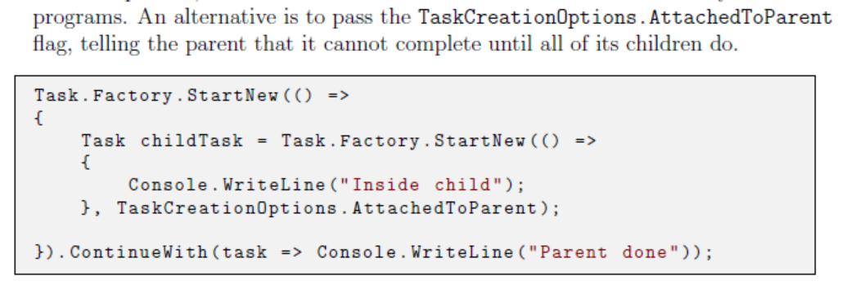

* TPL Dataflow

P228

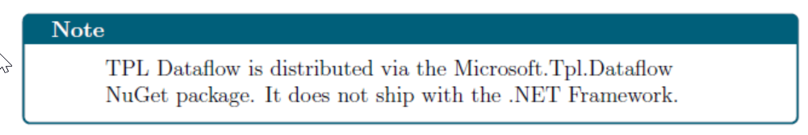

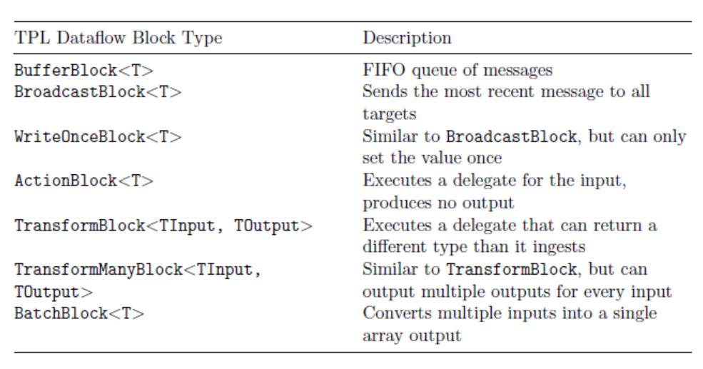

You can create your own block types by implementing the ISourceBlock<TOutput> and/or ITargetBlock<TInput> interfaces.

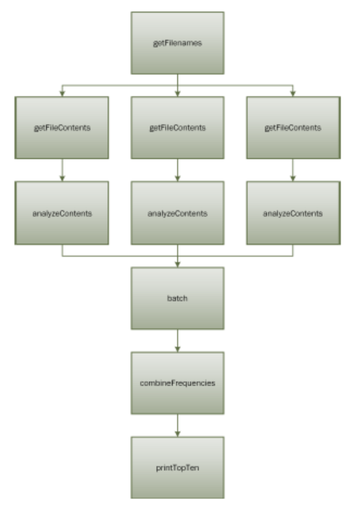

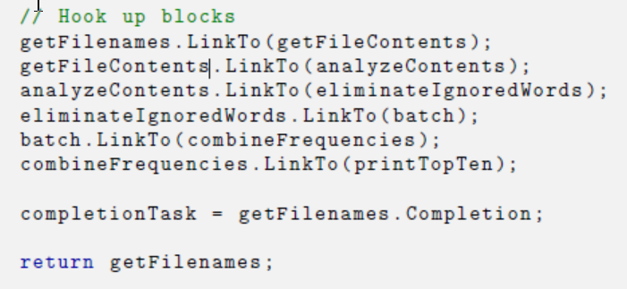

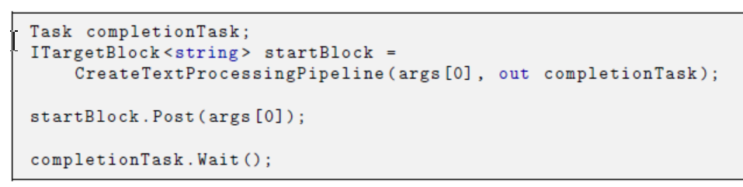

## Parallel Loops

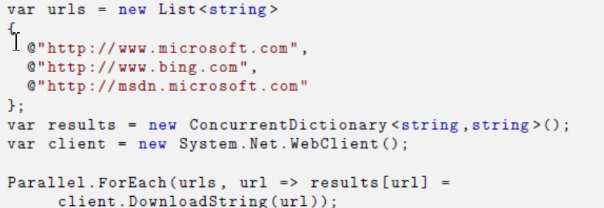

用loopState来Break, Continue

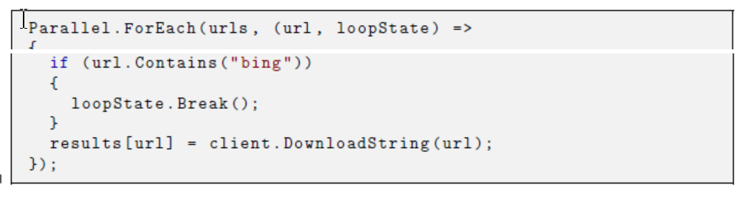

* Parallel and lock – Partitioner

有时候并行中执行的delegate本身很快但需要lock结果会损失性能，或者delegate的创建消耗很大。可以用Partitioner先将0到Max分块，块与块之间并行，块内串行 ，减少整个并行Foreach的个数，也就减少了 Lock的 次数，减少了delegate的个数

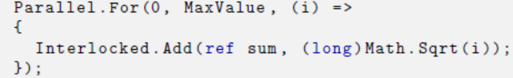

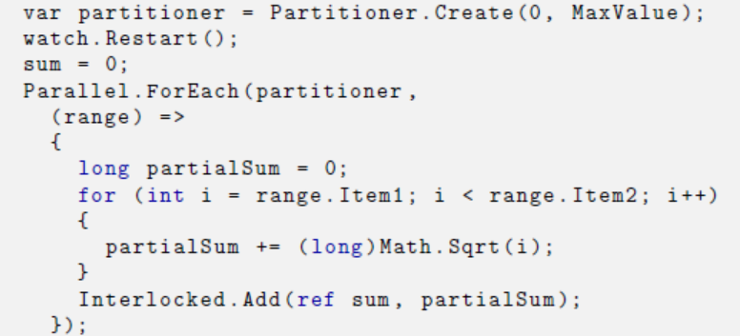

For more information and to see some extensive examples, search for the article, “Custom Parallel Partitioning With .NET 4" by Stephen Toub .

* Avoid Blocking

A common restriction for UI applications is that the UI state can only be modified from a single thread, often termed the \dispatcher" thread.

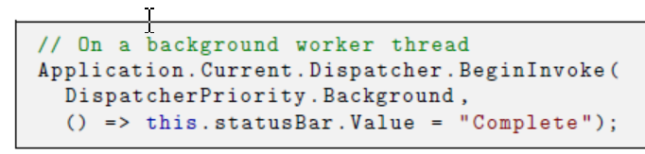

* 无法事先确定中止条件的Task，通过TaskCompletionSource<T>设置Task.Result返回方式 - 异步Stream读取与Dispose

当需要动态判断Task是否完成，然后返回结果是可以使用TaskCompletionSource<T>. TrySetResult. 动态判断到结束后，还需要手动dispose

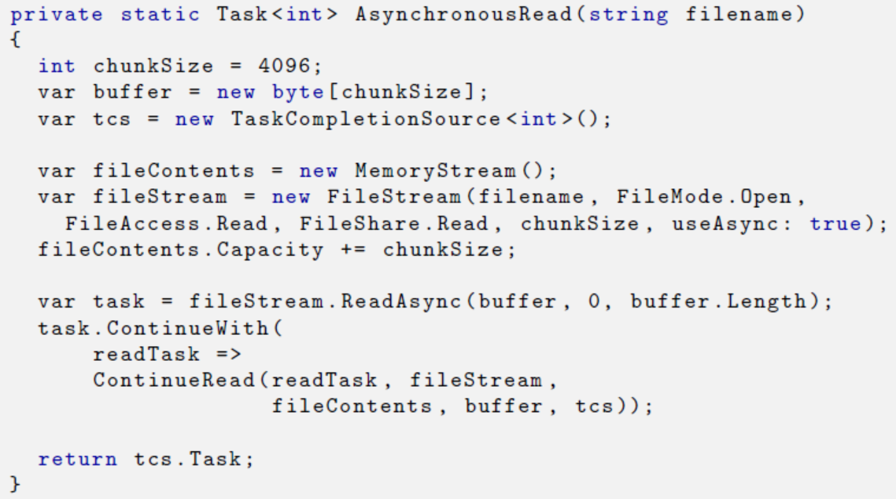

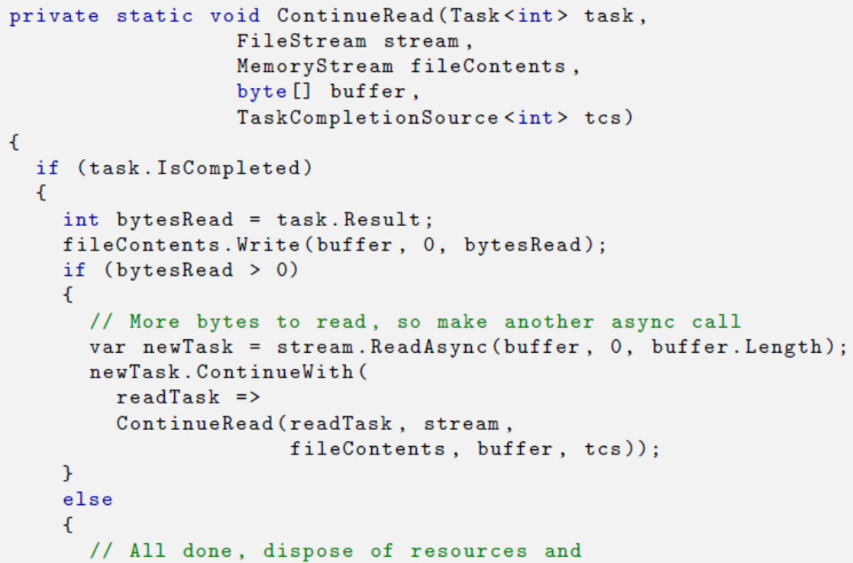

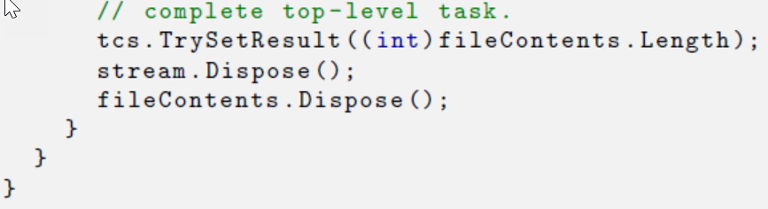

### Task与Async Functions

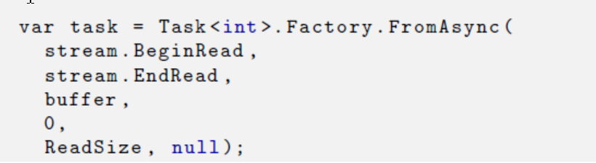

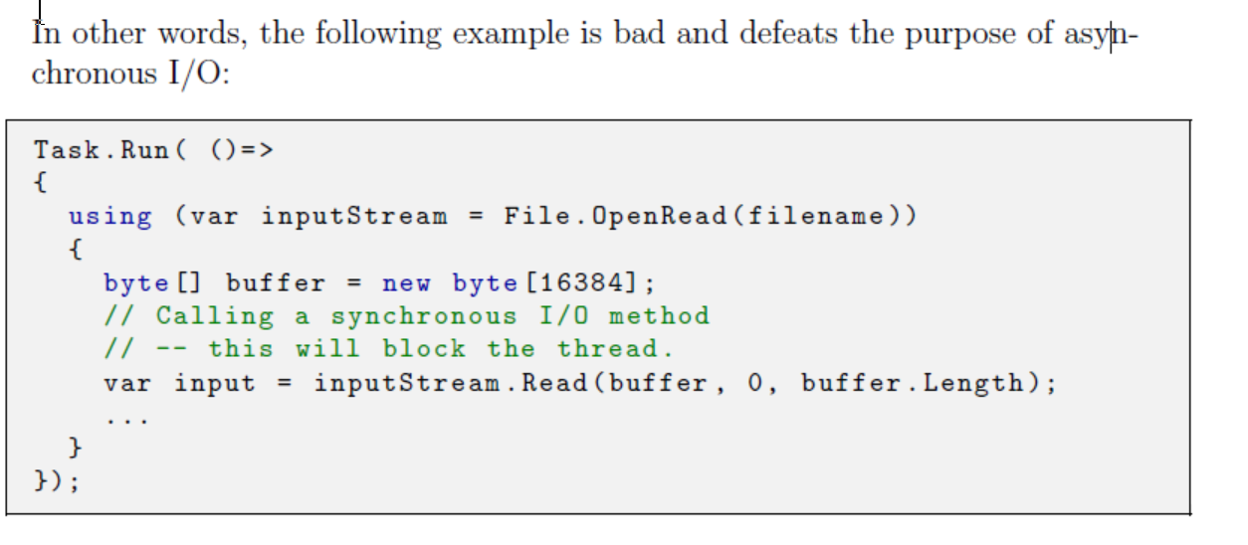

* Await / async

Everything before the await keyword happens in the calling thread. Everything from the await onwards is in the continuation.

there are some Task-based situations for which they cannot be used. For example, if the completion of a Task is nondeterministic, or you must have multiple levels of Task objects and are using TaskCompletionSource<T>, then async/await may not it.

* Timers

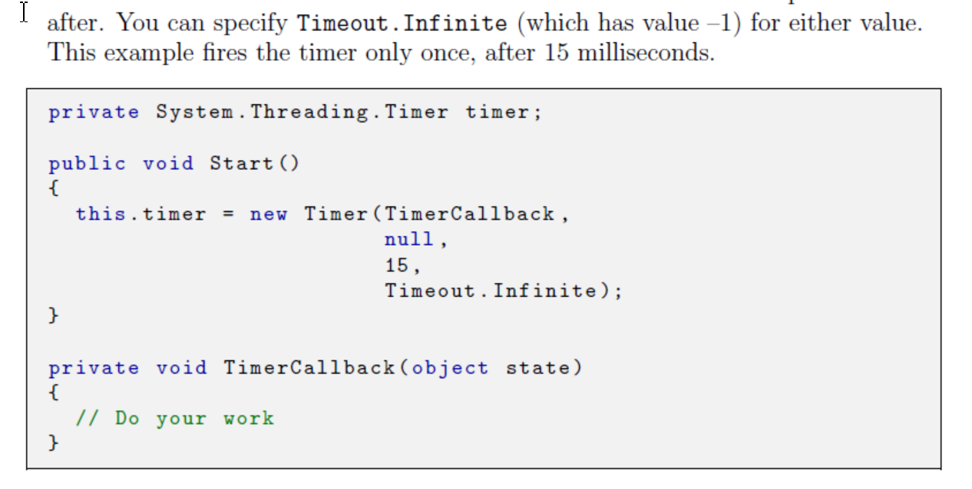

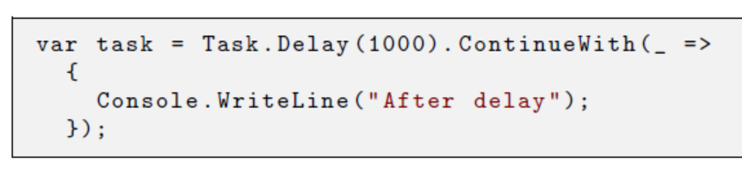

### Thread Synchronization and Locks

同步是指只有一个线程可以访问共享的状态。Lock不会优化性能，Lock是付出性能来确保准确性。

Synchronization is the practice of ensuring that only a single thread can access some shared state, such as a class's field. One of the fundamental truth of locks is: Locking never improves performance. We tolerate this because the one thing more critical than raw performance is correctness.

如果对性能要求不高的部分也用线程优化，会导致到处用lock，如果还用了线程池，那么一个不要紧的工作lock住了，会导致线程池多开其他线程来应对其他工作，最后反而造成了性能问题了。所以要思考是否需要优化。

If your non-critical piece of code is executing on a thread pool thread, and you block it for a signi_cant amount of time, the thread pool could start injecting more threads to keep up with other requests. If a couple of threads do this once in a while, it is no big deal. However, if you have lots of threads doing things like this, then it could become a problem because it wastes resources that should be doing real work.

最佳状态时完全没有同步

If you can completely remove your need for thread synchronization, then you are in the best place as far as performance goes.

多个线程一起读一个变量不用同步；多个线程一起写一个变量可以改成各自写进本地变量，再从本地变量进共享变量，少Lock几次

You will need to convert repeated access to a shared variable to repeated access of a local vari-able followed by a single shared access,

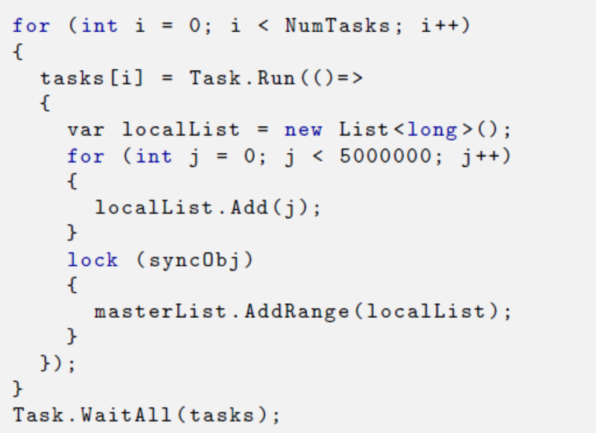

In general, consider synchronization mechanisms in this order:

lock/Monitor class: Keep it simple, understandable, with a good balance of performance.

No synchronization at all: Remove shared mutable state, refactor, and optimize. It is harder, but if you can do it, it will usually perform better than using a lock (barring mistakes or detrimental design changes)

Simple Interlocked methods: They can be more appropriate in some scenarios, but once the situation becomes more complex, turn to a lock.

* Memory Models

The memory model is the set of the rules in a system (hardware or software) that govern how read and write operations can be reordered by the compiler or by the processor across multiple threads.

强内存模型和弱模型是指是否允许重新排列指令的顺序，通常是允许一些，不允许另一些。限制越多越强。 JIT需要保证不能重排的指令真的没有重排，要做到这一点JIT需要生成这方面的指令，因此性能就会受影响。8086 strong，ARM weak

A \weak" model allows the compiler and processor much more freedom to reorder read and write instructions in order to get potentially better performance. It is the JIT compiler's responsibility to ensure that not only are machine instructions emitted in the proper order, but that special instructions are used to ensure that the processor itself does not reorder instructions in a way that violates the CLR's memory model.

Volatile是告诉JIT，重现排列读写该变量的指令是会有影响的，要保证顺序，没有性能损失。

The biggest requirement here is the correct use of volatile on state that is shared between threads. The volatile keyword is a signal to

the JIT compiler that ordering matters for this variable. On x86/x64 it will enforce instruction ordering rules, but on ARM there will also be extra instructions emitted to enforce the correct semantics in the hardware.

Lock内部的顺序都会保证，不会重排，

* Use volatile When Necessary

保证在所有CPU上所有线程读出来都是同样的内容。可以看Lazy<T>的源代码

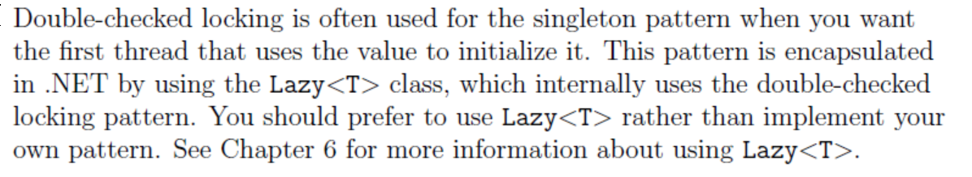

* Use Monitor (lock)

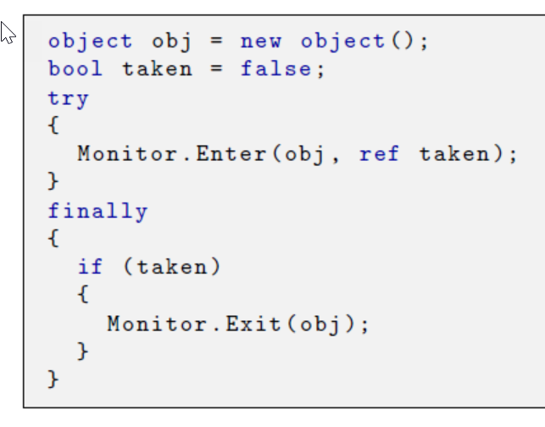

The Monitor class takes a synchronization object as its argument. You can pass any reference type object into this method. it is almost always wise to allocate a plain, private object specially for your locking purposes, as in the examples above.

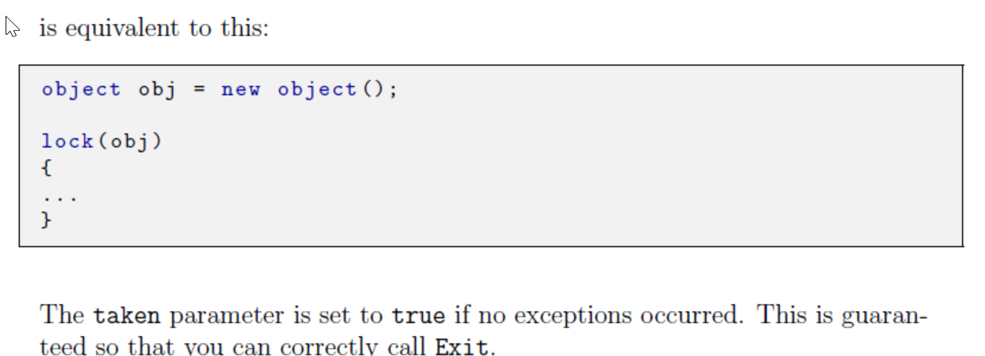

### Lock At a Higher Level

In many cases, making batch updates under a single lock is better than taking a lock for every single small update.

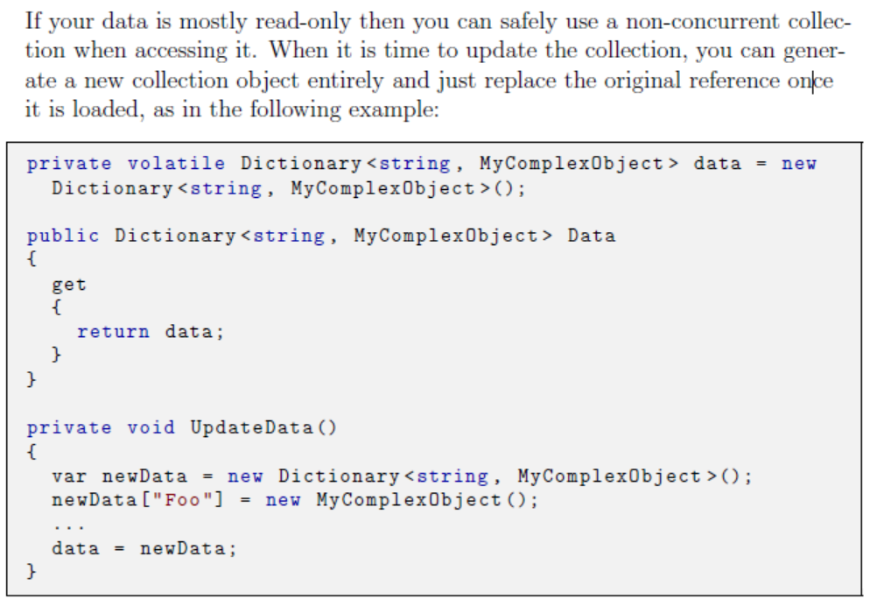

* 用ThreadLocal<T>来分拆对象到每个线程

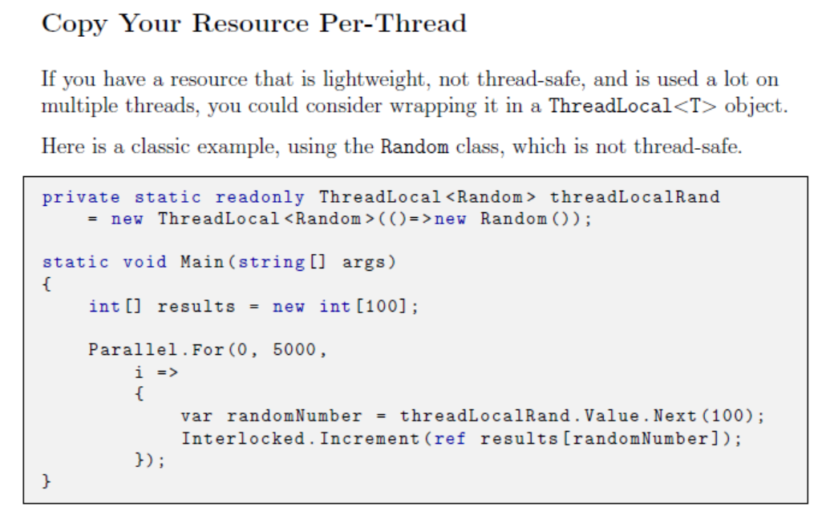

* 用Interlocked代替Lock

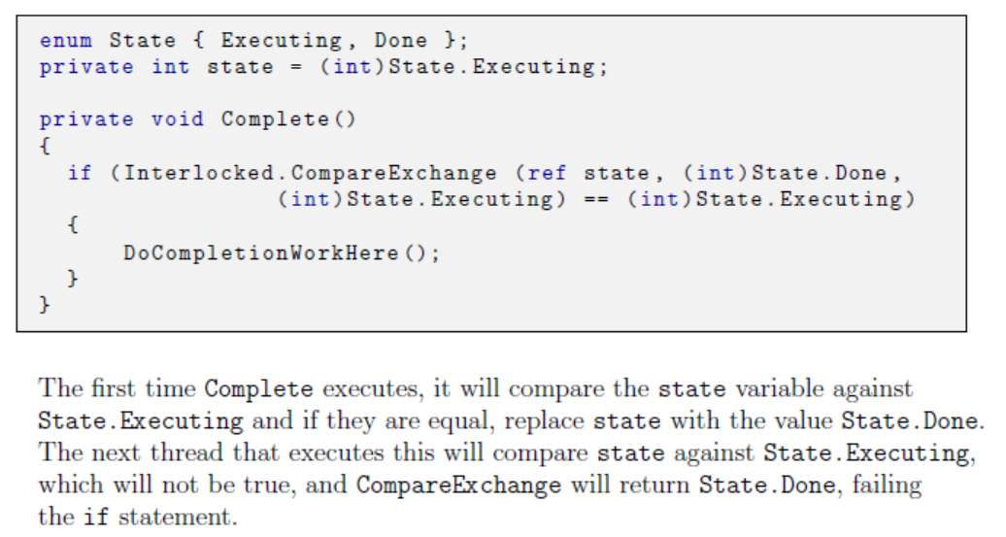

Interlock最后都是单一指令，原子执行。如果要用到很多Interlock还不如开一个大的Lock

Interlocked methods translate into a single processor instruction and are atomic.

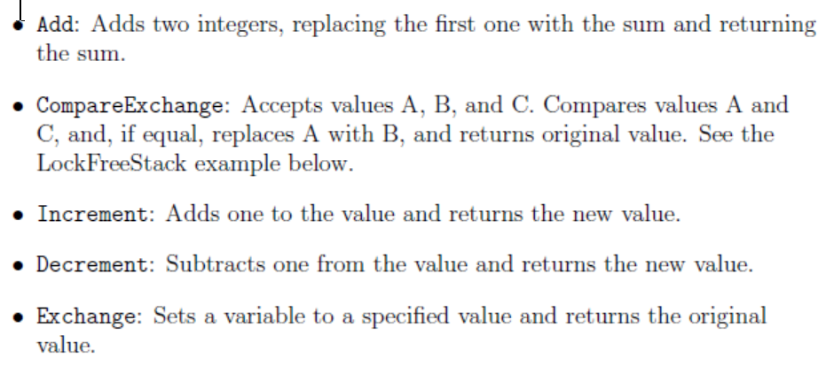

### Investigating Threads and Contention

* Performance Counters

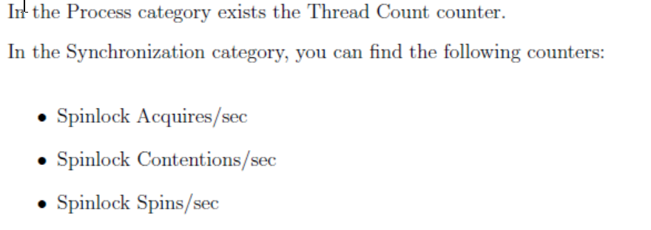

* Visualizing Tasks and Threads with Visual Studio

Visual Studio has an optional tool called the Concurrency Visualizer.

Launch the Pro_le Wizard (from the Analyze | Performance Profiler. . . ) and select the concurrency option.

* Using PerfView to find Lock Contention

Run the program and collect .NET events using PerfView. Open the Any Stacks view and look for an entry named

\Event Microsoft-Windows-DotNETRuntime/Contention/Start"

In PerfView's Collection dialog, check the \Thread Times" box

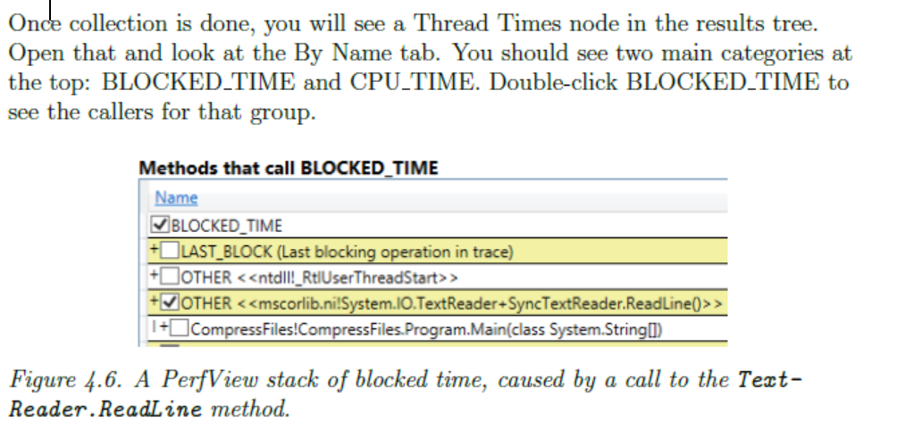

# CHAPTER 5. General Coding and Class Design

### Classes and Structs

Class的实例在堆上，靠引用传递，通常拷贝引用只有4（32位）或8bytes. 每个对象有8bytes或16bytes的额外内存占用，包括虚表指针与sync域。还会有额外的内存用于内存对齐

Struct值对象没有额外内存占用，如果是局部变量就分配在栈上，如果是类的成员就在堆上，所以传struct给函数会拷贝全部存储，因为函数变量不在堆上，但可以传递其引用。分配Struct不会引起GC。

An array of structs has many sequential values in memory. Accessing an item in the struct array is very simple. Once the correct entry is found, the right value is there already. This can mean a huge difference in access times when iterating over a large array. If the value is already in the CPU's cache, it can be accessed an order of magnitude faster than if it were in RAM.